Ecarter Vendor App: Ecarter Vendor App provides facility to access your Cs-Cart vendor panel using mobile, to access your vendor panel simply you just need to install Ecarter Vendor App in your mobile devices and you can start managing your vendor panel by login with your vendors user-id and password.

Features:
- Well integrated with the existing CS-Cart multi-vendor store.
- Vendors can manage products like add,delete,edit,update,search products.
- Vendors can see all sales statistics like income,sales,current balance,active products,products inventory using the dashboard of the app.
- Vendors can see orders, manage orders statuses using this app.
- Vendors can update their self profile,company profile with this app.
- This app supports multiple languages,vendors can choose language according to their needs.
- This app provides a feature of contact using whatsapp.
- This app provides a feature of push-notifications related orders statuses and Admin notifications.

Benefits:
- Benefits manage Vendor Panel across mobile devices.
- Well supportive in terms of accessibility and reach-ability.
- User-friendly interface provides

Ecarter Vendor App Addons Settings:
- Admin can set ios/Android Api version from addons settings.
- Admin can set mandatory app updates from addons settings.
- Admin can set whatsapp redirect link, can update contact number from addons settings.
Note: This setting is only applicable for the admin of the store.

Screenshot of Ecarter Vendor App Settings:
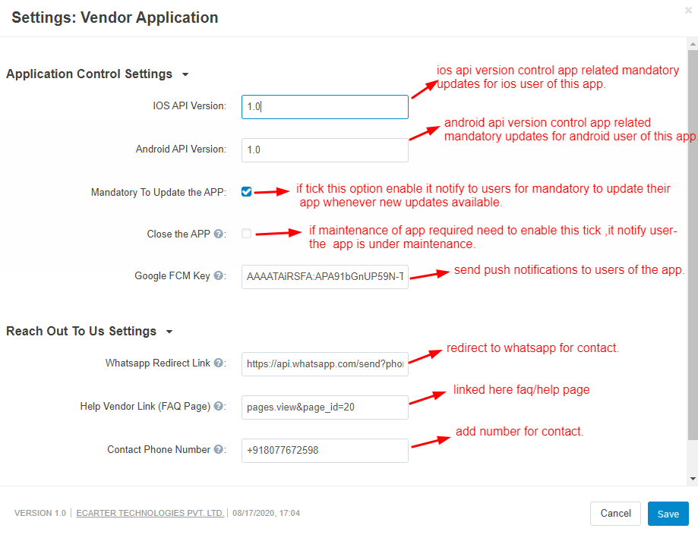

Firebase Cloud Messaging for push notifications: this feature provides push notification service to admin which helps send push notifications to vendors by admin of storefront. Also it is notified to vendors when vendors change order status of any order.

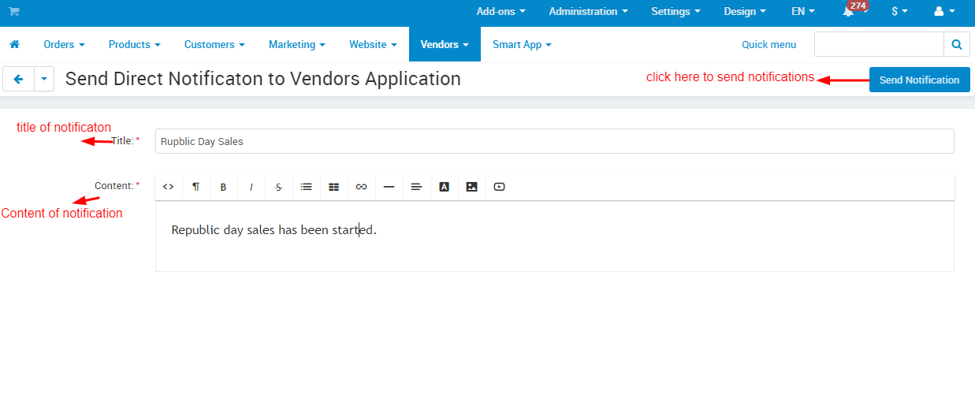

Note: Only Admin can send notifications to vendors from here.

Screenshots of push notifications on frontend:

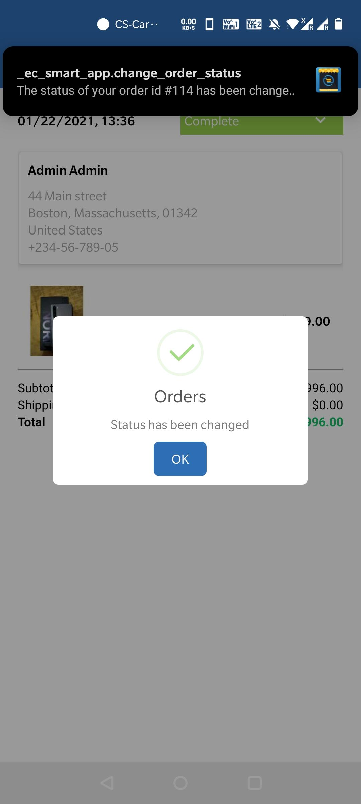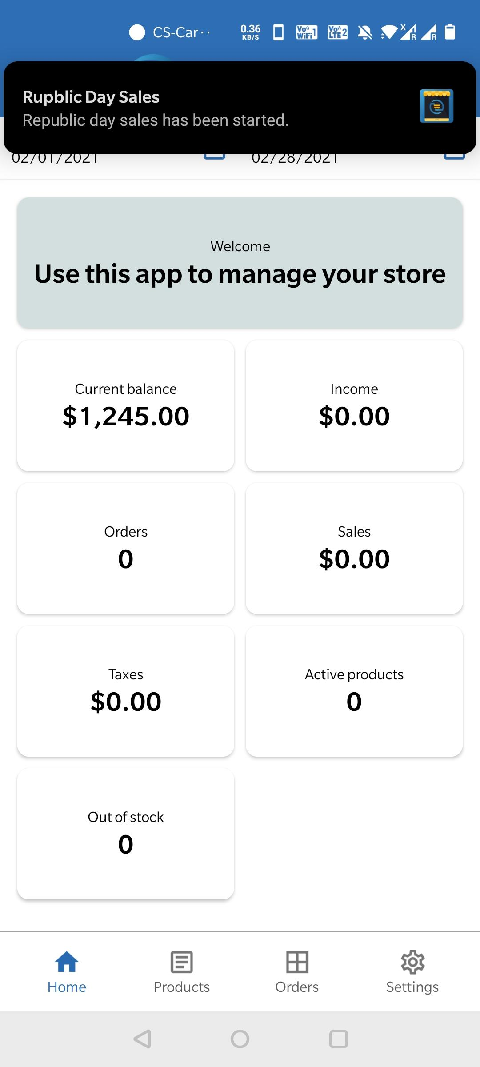
img a:vendor change order status notification img b:vendor get notify by admin of store

Img a: vendor gets notified through a push notification whenever he changes the order statuses of any order.

Img b: in the second screenshot vendors get notified by the admin of the store related to the republic day sales.

USER GUIDE:

Frontend Of Ecarter Vendor App:

Splash:
The launching screen of the app can be amended from the code end and will appear to the users as they open up the app. Thus, helping the app owner to introduce the app or organization in a better way.

Img 1.1 : splash screen

After Splash Screen Users can choose language for processing App in particular selected language.
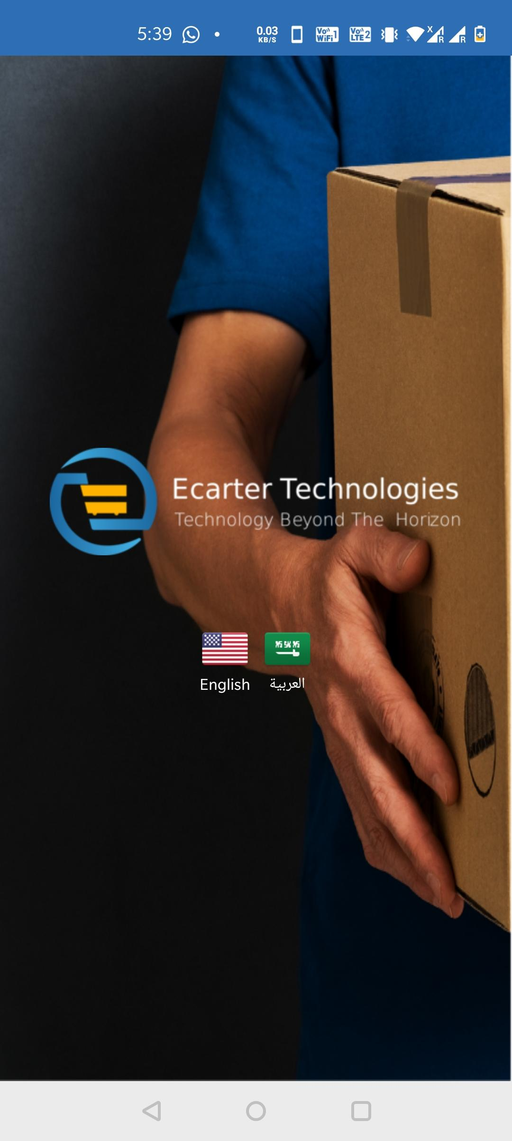
Img 1.2: Choose language for processing app

After selecting language the app will be processed for use and there are two options on the app user screen.

- Login: Register users can login using their login details (user id and password).

- Register: New users can register to them-self by filling contact information and details.

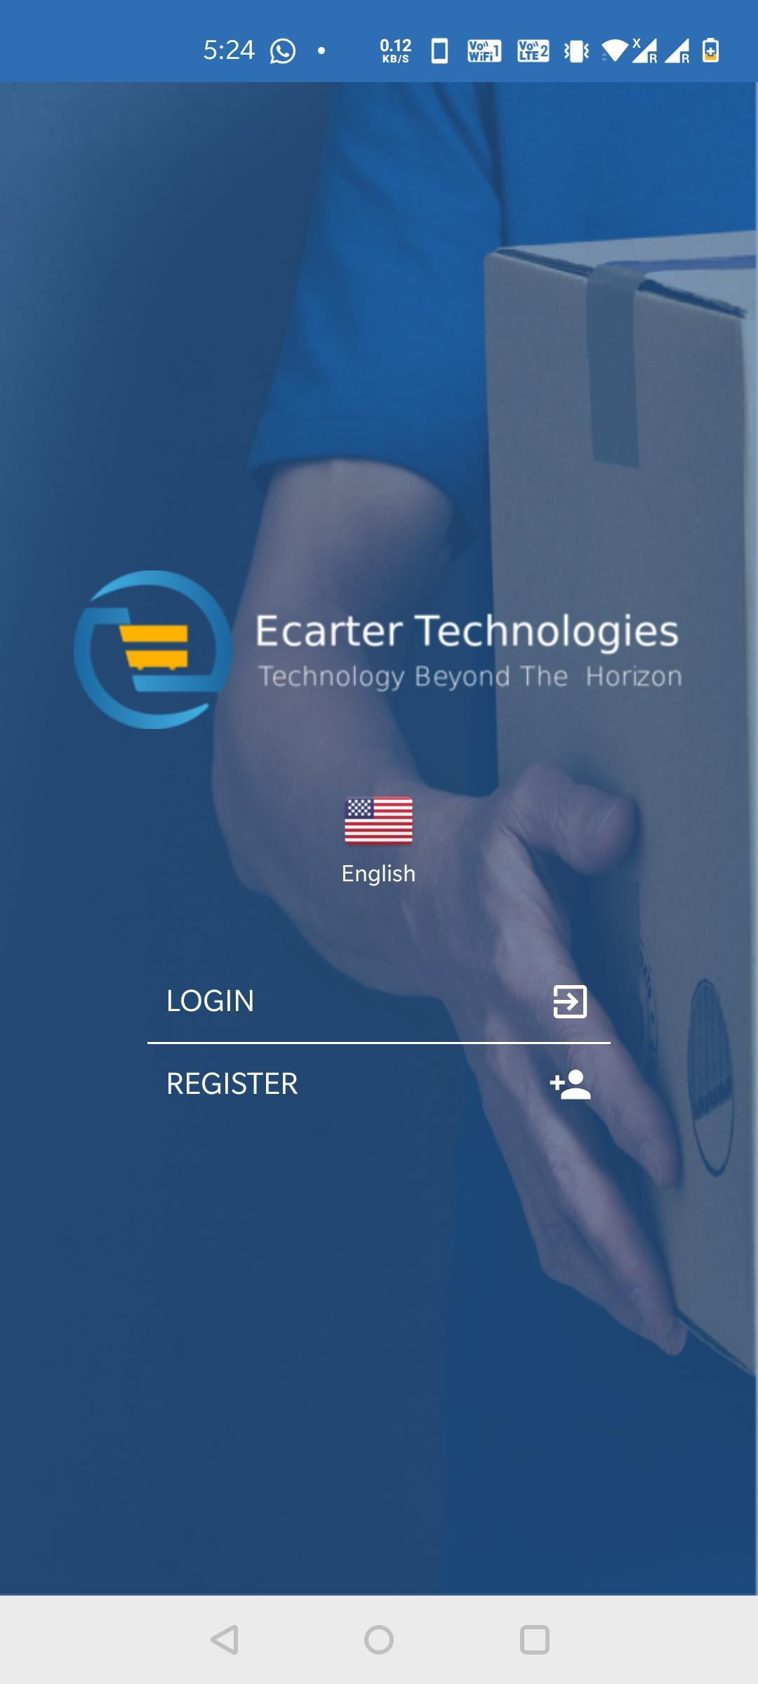
Img 1.3 Login/Register Screen

Registration: Click on register,user can fill contact information and company details for registration. As you can see in the screenshots (Img 1.4: Registration) a registration popup message appeared after a successful registration.

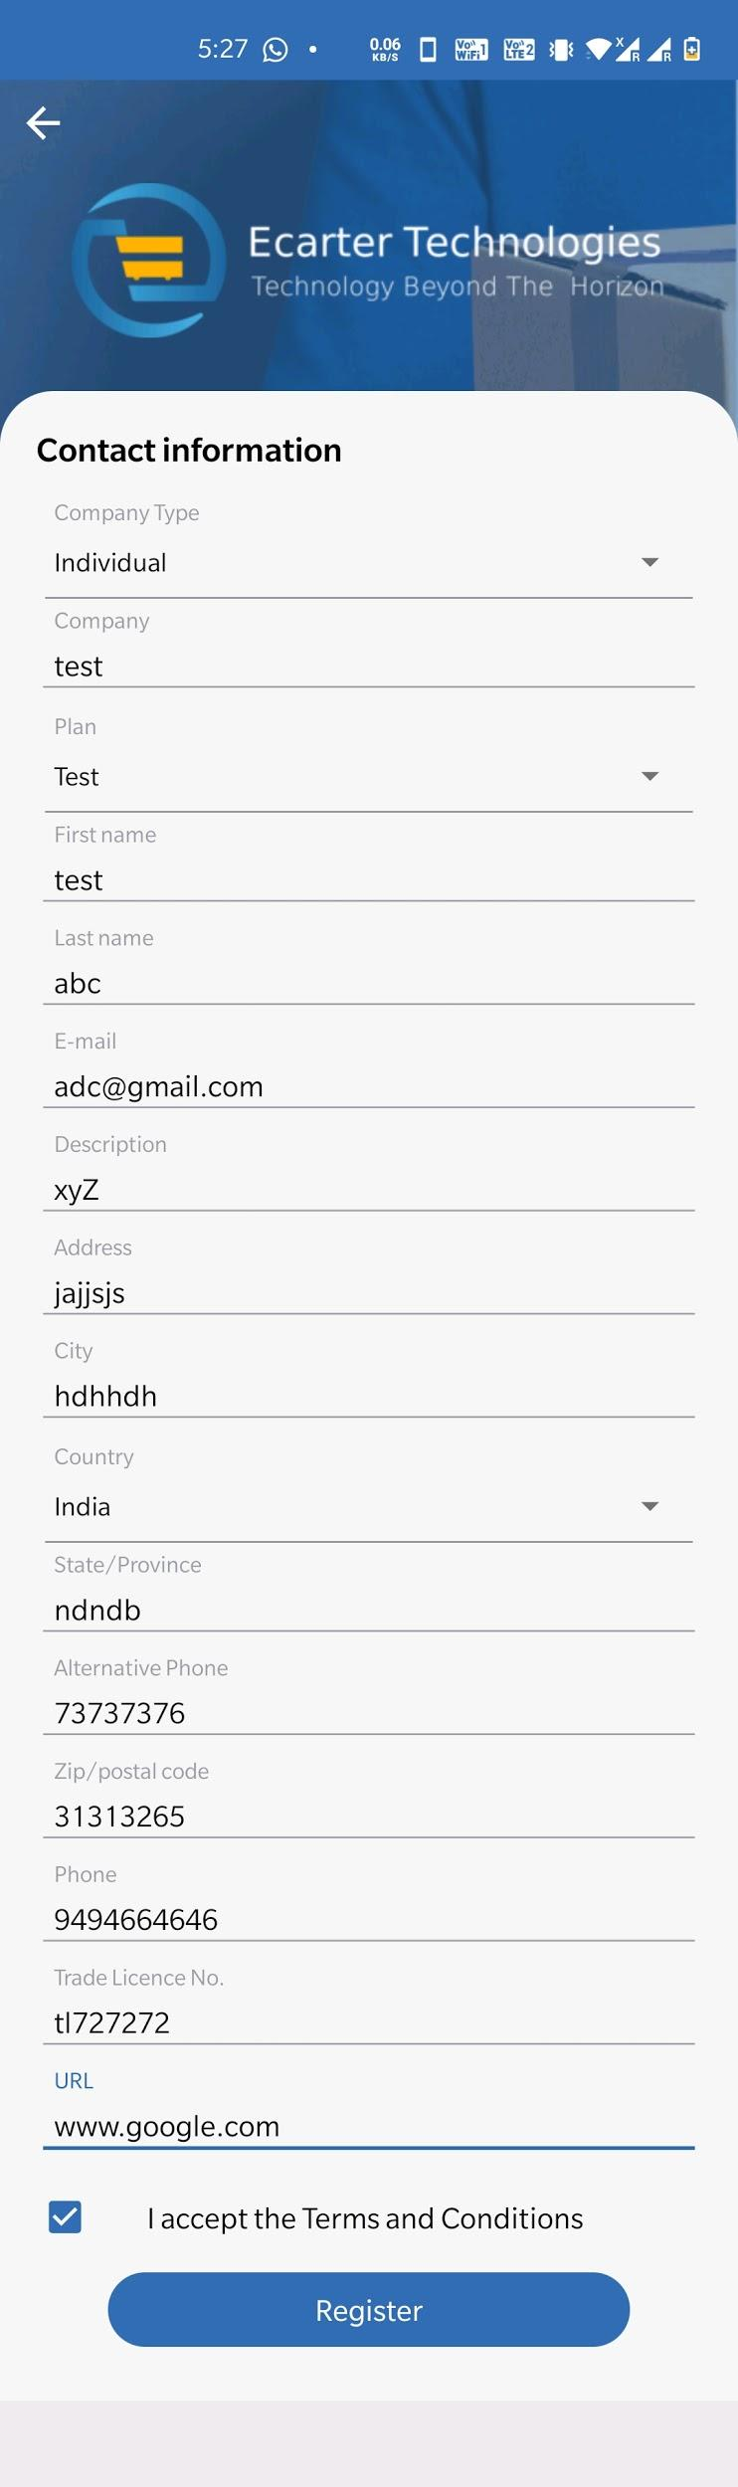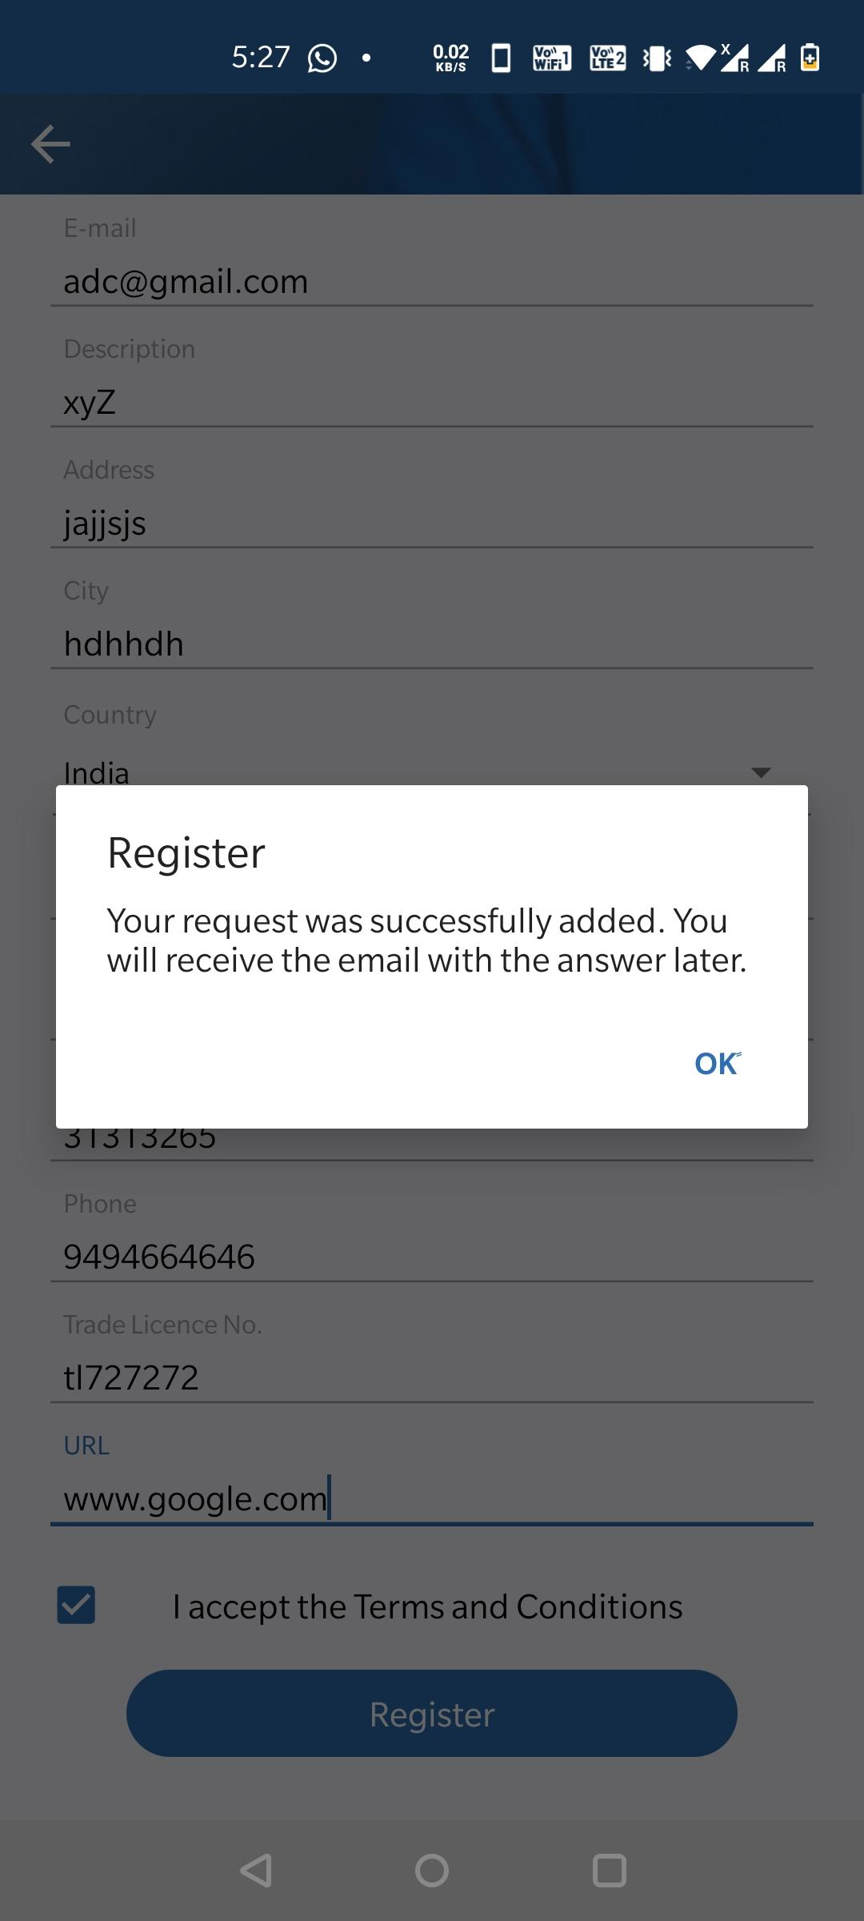
Img 1.4: Registration

LOGIN : Click on login then enter User Name and Password then click on login.

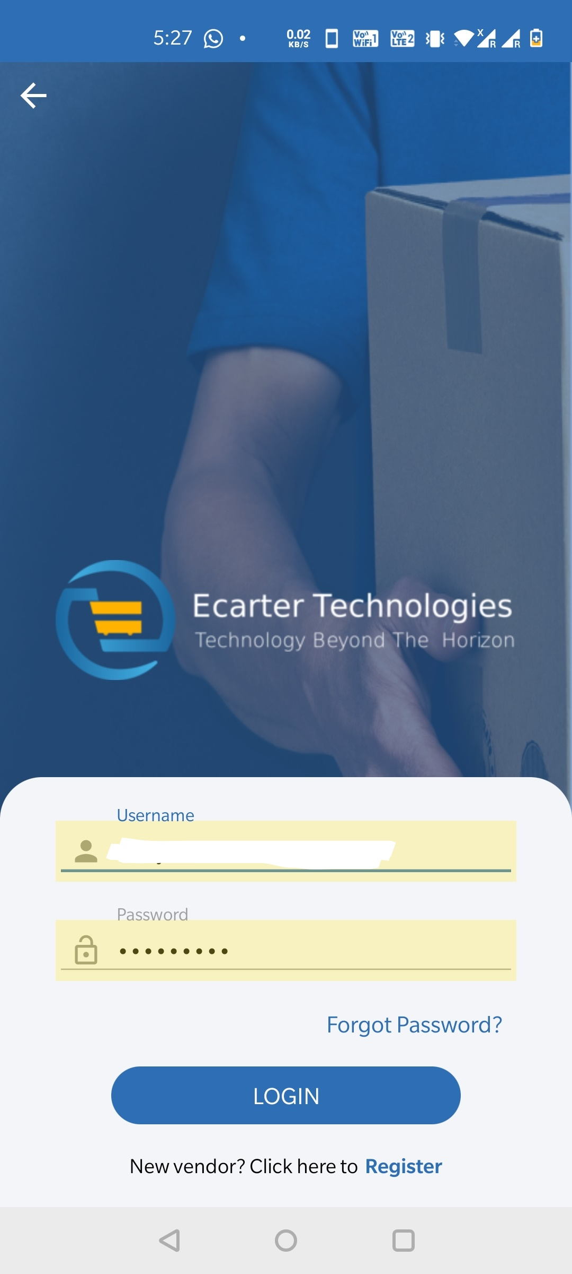
Img 1.5: Login

Homepage/Dashboard:
The homepage of the app is divided into two sections-

- First is the dashboard of the app where users can find all sales statistics like income,sales,current balance,active products,products inventory by date to date There is option of selecting date From and To date.
- The second one is a navigation drawer. The navigation drawer has multiple options for the app user to use-
- Home : It is situated on the bottom of the homepage where the users can click and go to the dashboard or homepage of the app where they can find all sales statistics like income,sales,current balance,active products,products inventory.

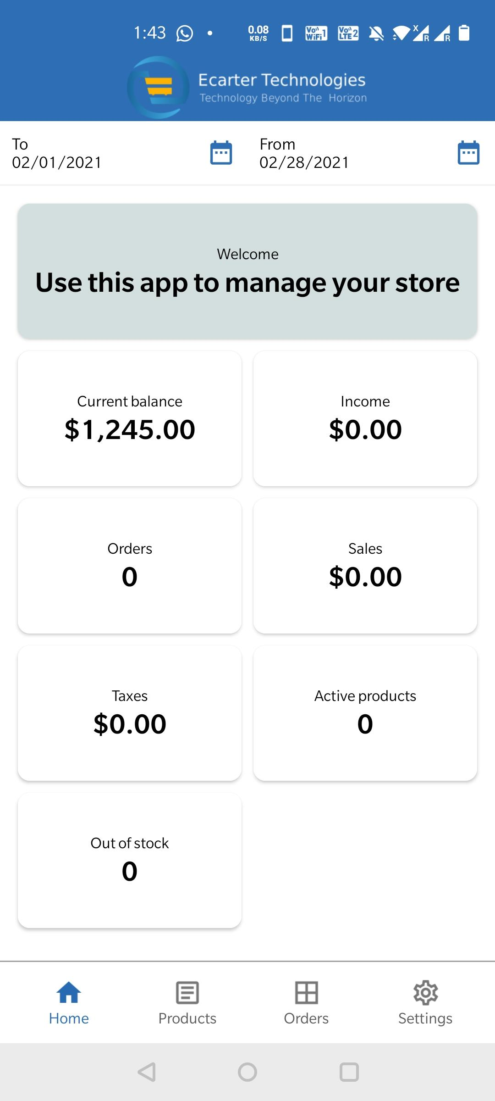
Img 2 : Dashboard/Homepage
- Products : it's also situated on the bottom of the homepage where users can click and go to the products sections where they can see all added products,they can add new products ,edit products, delete products and search products.

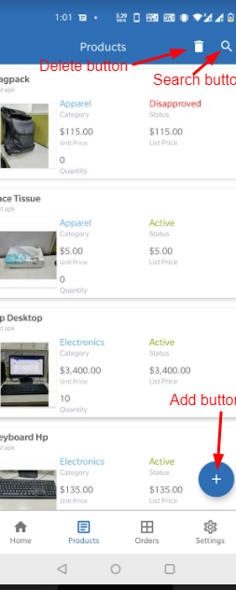
Img 3.1: ALL ADDED PRODUCT

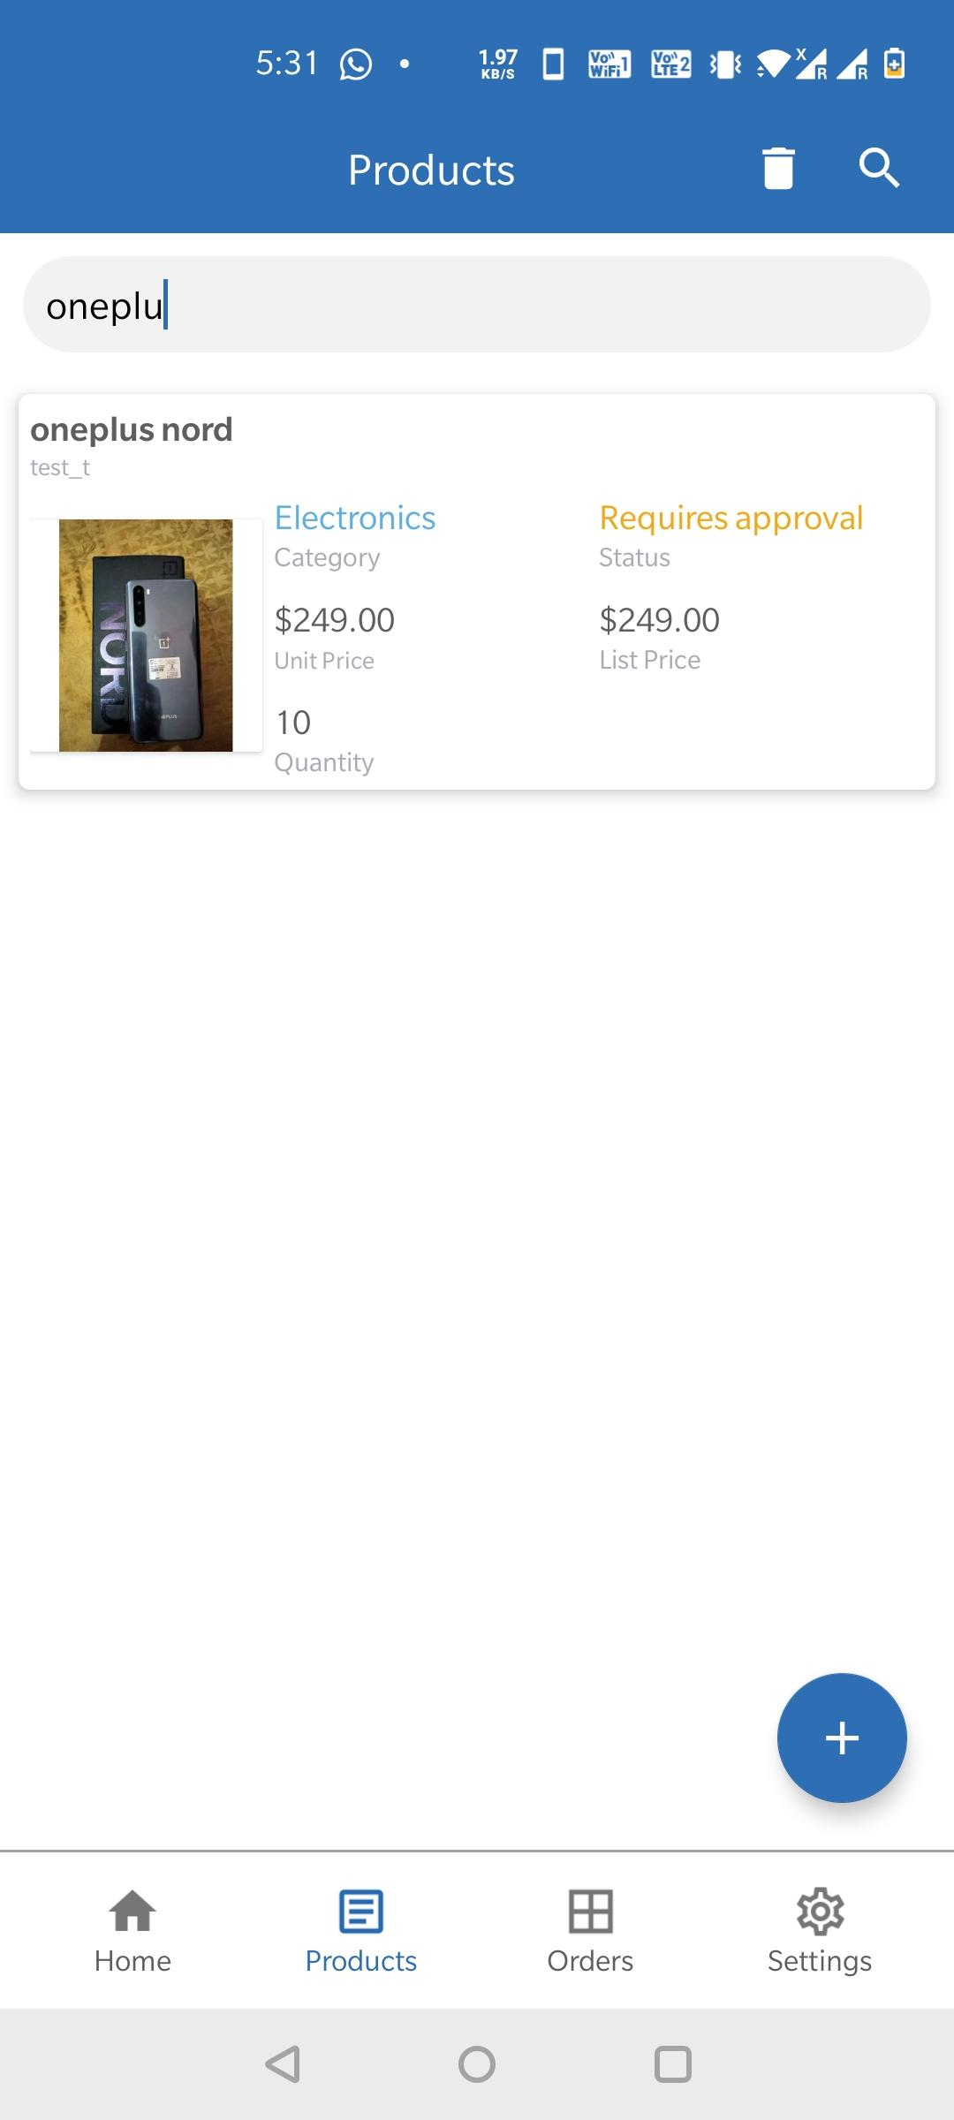
Img 3.2: Search Products

Img 3.2: Search Products: Here you can see a magnifier which is also known as a search button user can click on that for a search product by just entering keywords like-product name, product id. This make easier whatever you want to find.

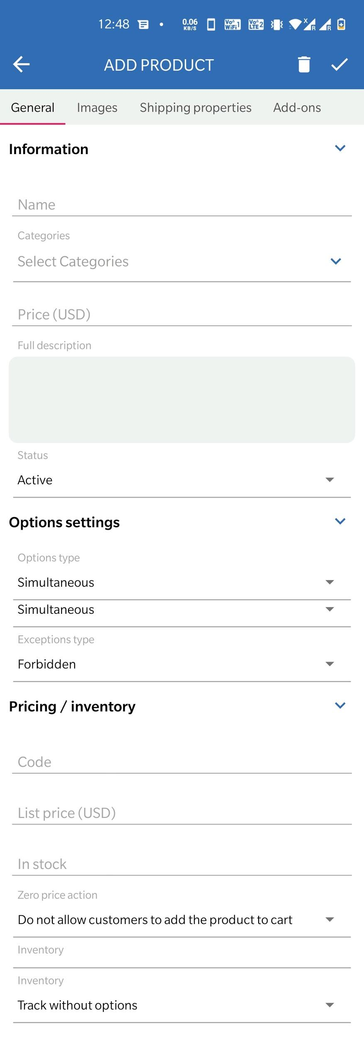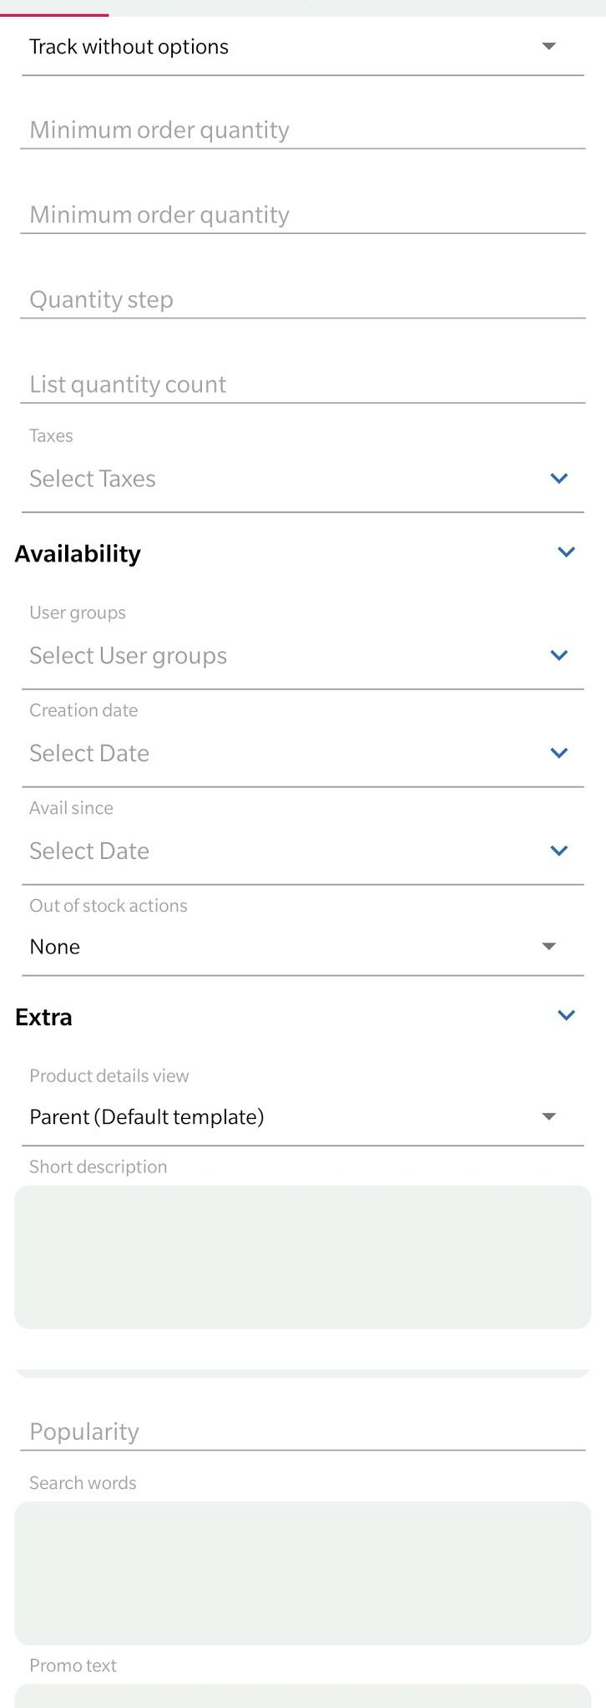

Img 3.3.1 :add product: add general info

Img 3.3.1 :add product: add general info : Whenever vendor/user want to add new products just click on add button(+) and enter the details like information(product name, categories of products,price),options settings, pricing inventory(like products code,stock unit,list price),availability( like assign user group ,available date,creation date of products) and in extra field user can add search words for products,promo text).

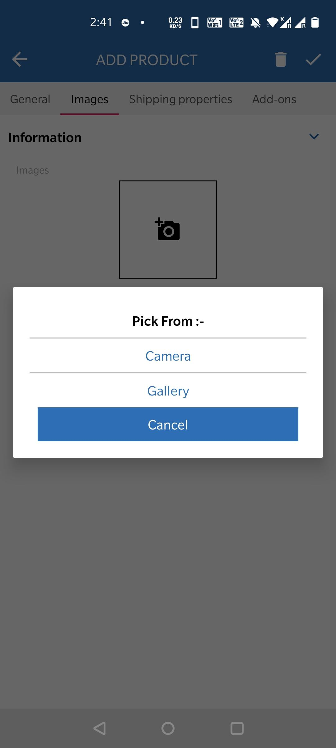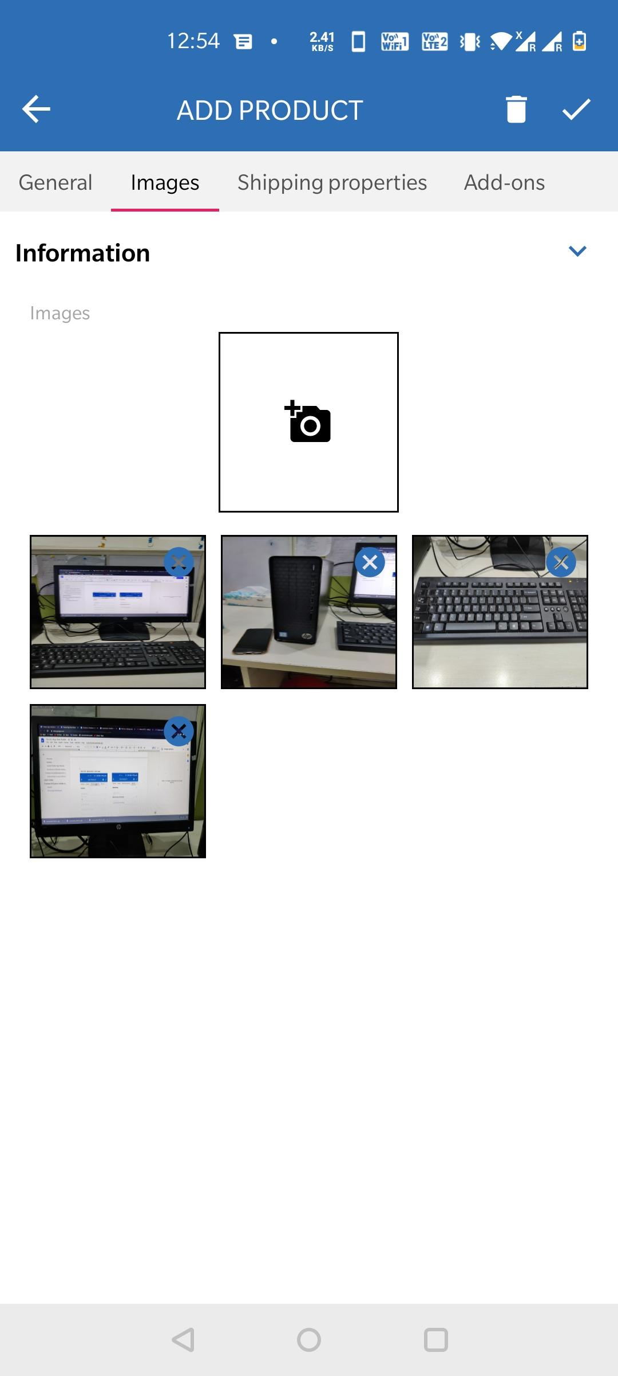

Img 3.3.2 : add product : add image

Img 3.3.2 : add product : add image: in this section of adding a new product , users can add multiple images for their products from their phone gallery, they can also click and upload images. Like as you can see in the screenshot.

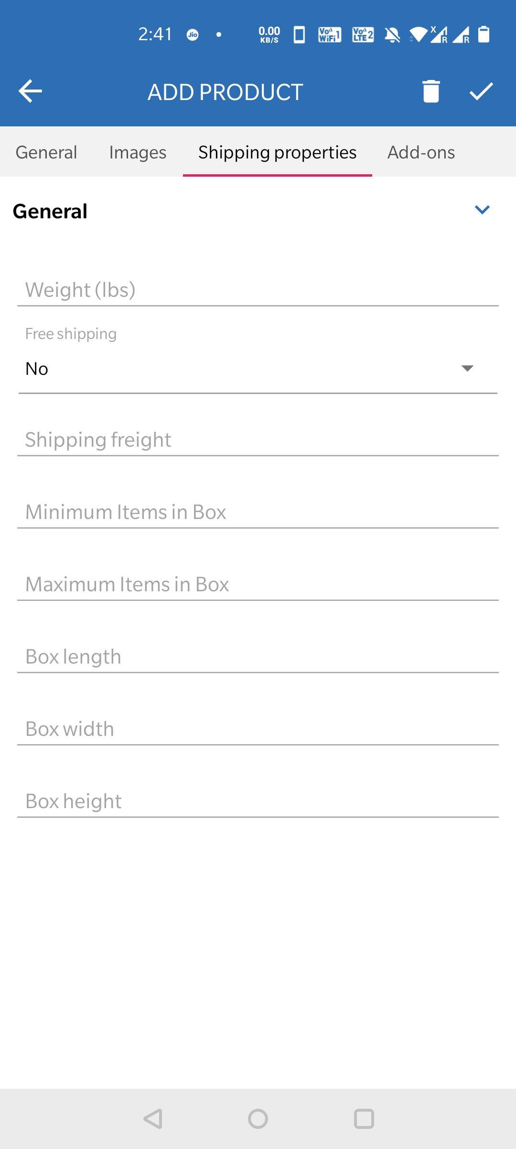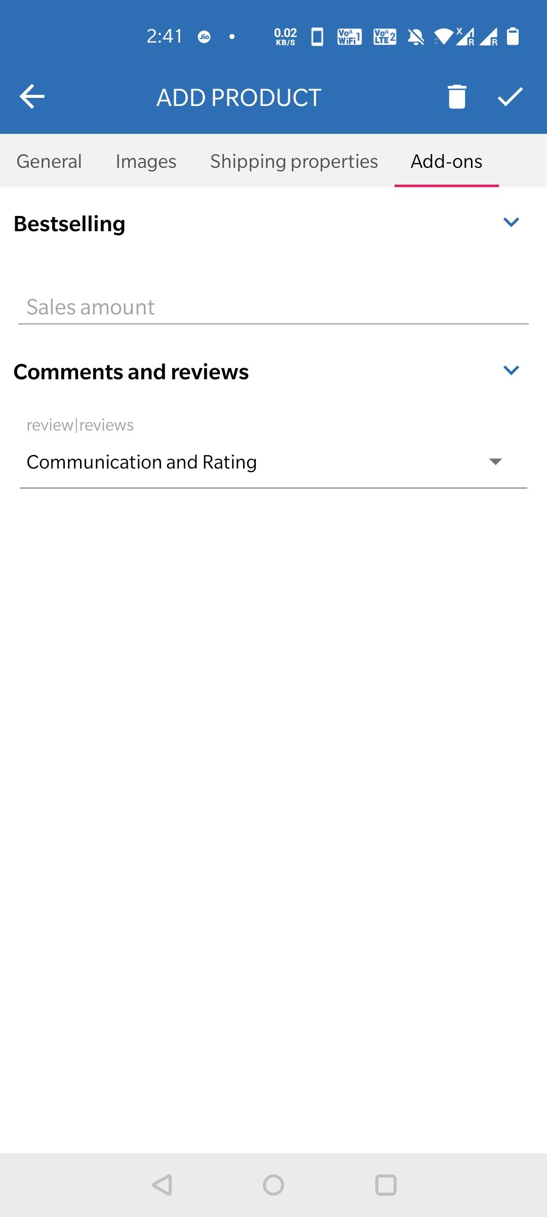
Img 3.3.3: add product :shipping properties Img 3.3.4 : add product : add addons

Img 3.3.3: add product :shipping properties: in this section of adding new products, users can add shipping properties of their product like, weight of products ,shipping methods,box contain items etc.

Img 3.3.4 : add product : add addons: after that in this section of adding new products , users can manage add-ons settings for their products.

Edit products: as you can see in the below screenshots-
- users can edit their added products like product information.(Img 3.4.1 : edit product: General info.)
- edit images which are uploaded at the time adding products images for any products.( Img 3.4.2: edit product: image )
- Users can edit options like color,size of added products.(Img 3.4.3: edit product:option,Img 3.4.4: edit product:option)
- Users can edit shipping properties which are added at a time of adding new products.( Img 3.4.4: edit product:shipping properties )
- Users can edit addons settings.( Img 3.4.5: edit product: add-ons)
- Also users can edit features for their added products.( Img 3.4.6: edit product: features)
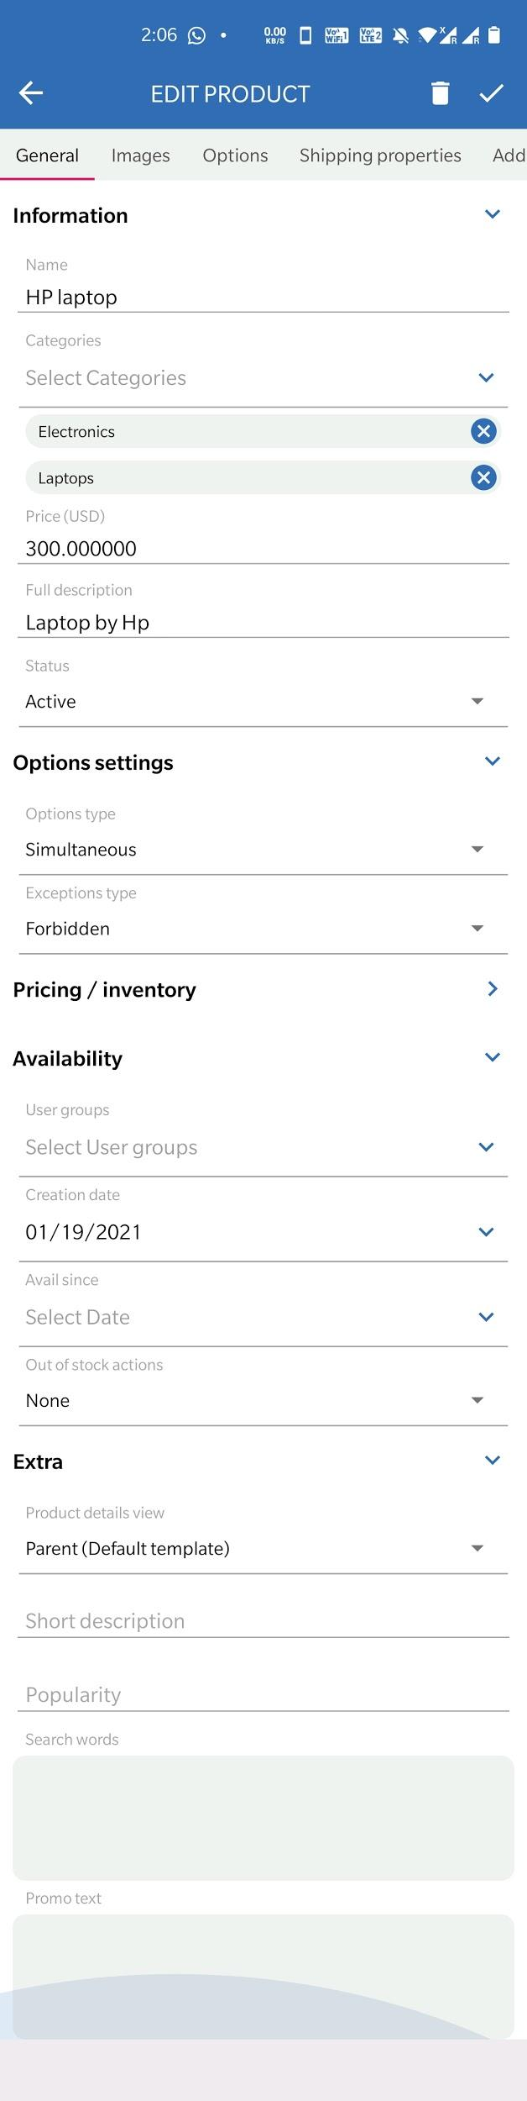
Img 3.4.1 : edit product: General info. Img 3.4.2: edit product: image

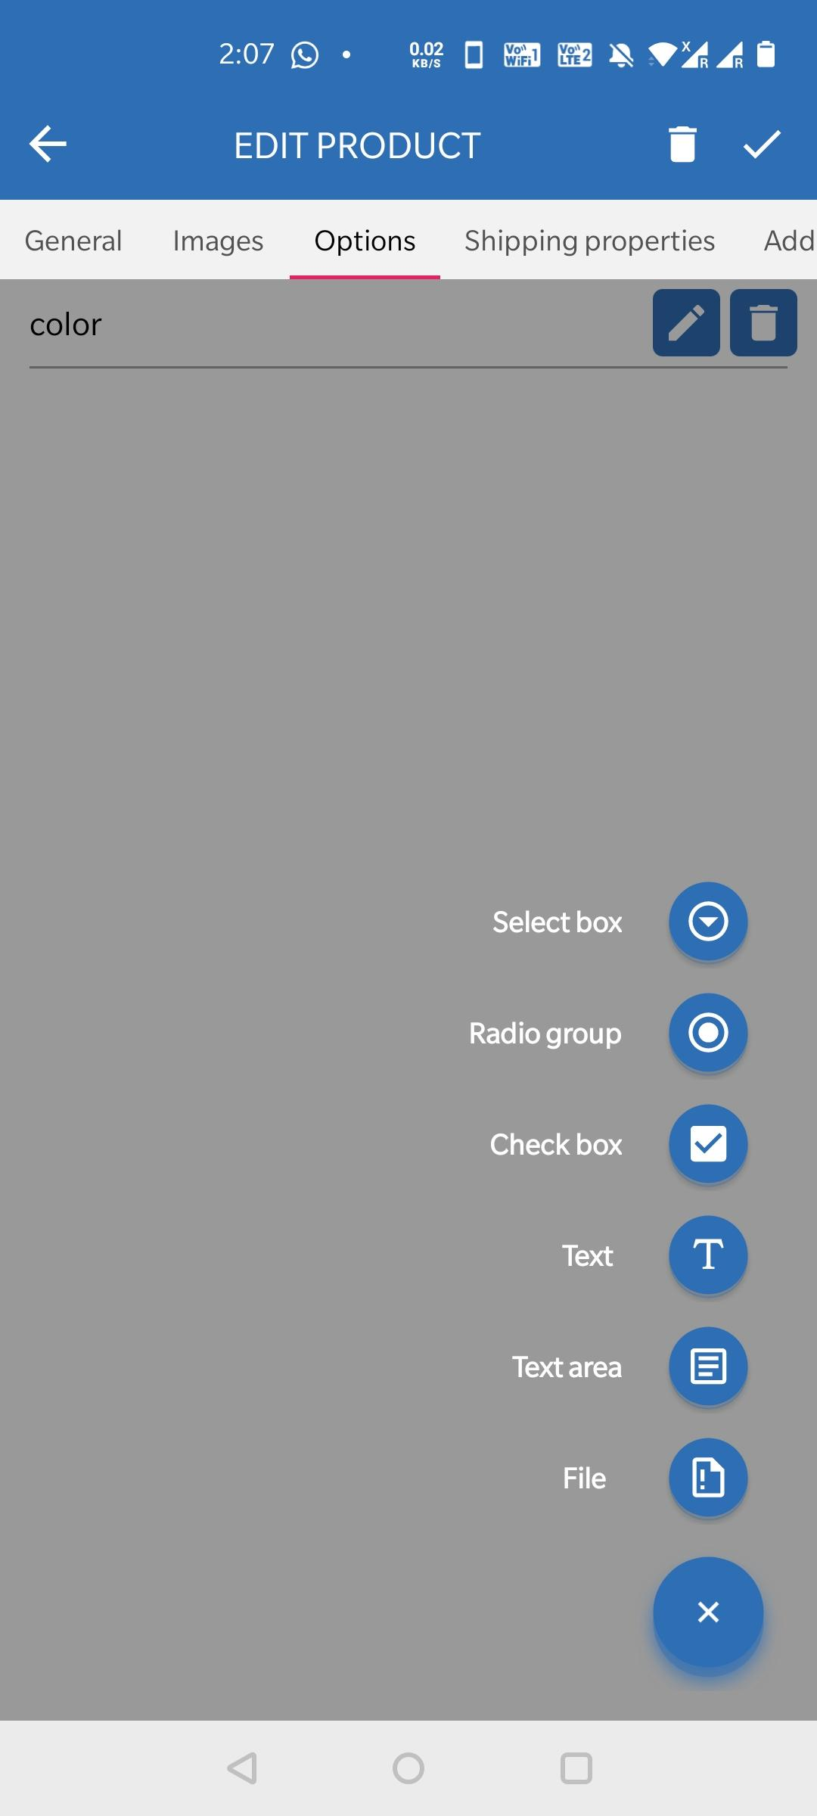

Img 3.4.3: edit product:option

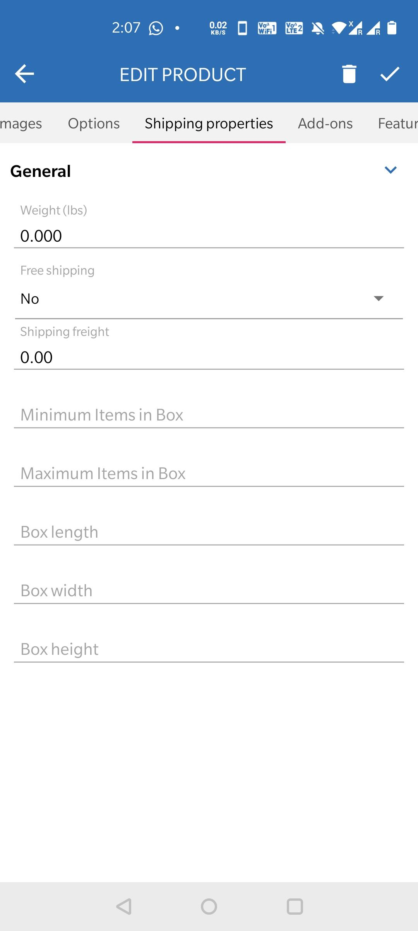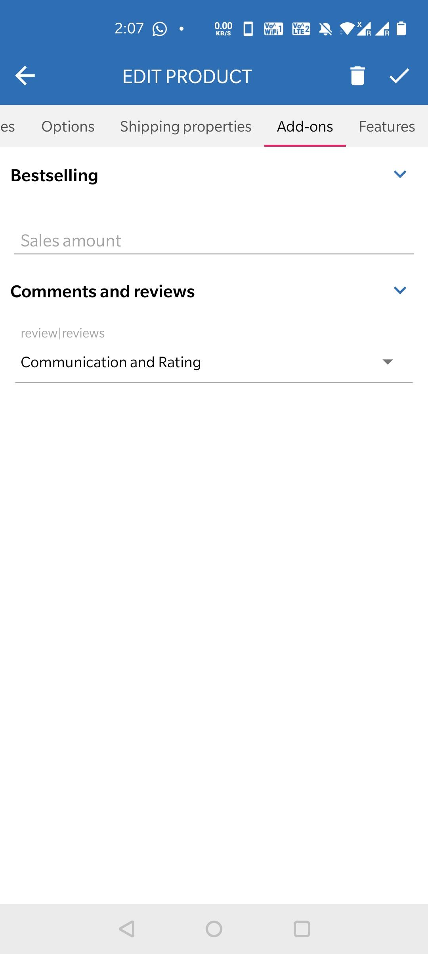

Img 3.4.4: edit product:shipping properties Img 3.4.5: edit product: add-ons

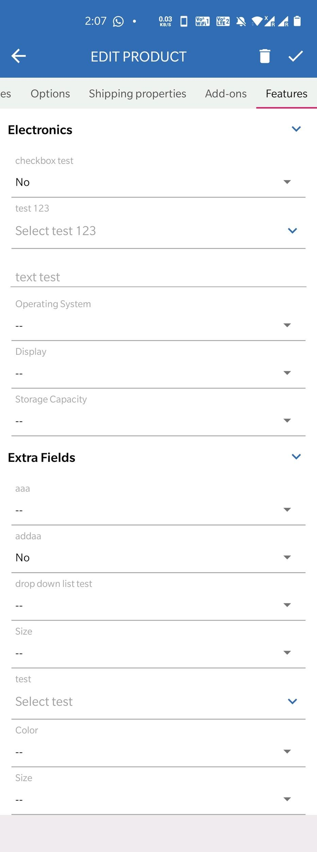
Img 3.4.6: edit product: features

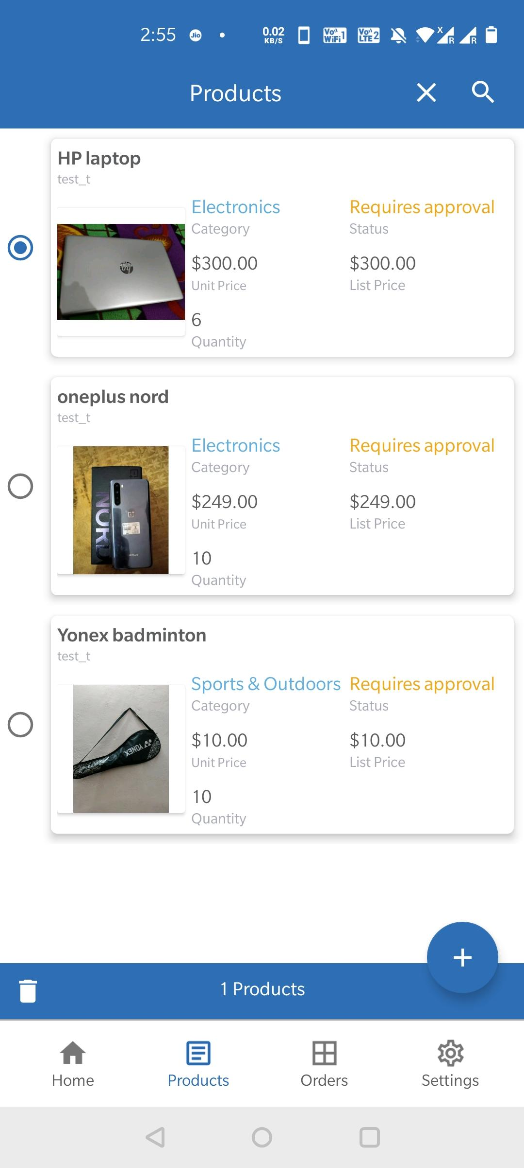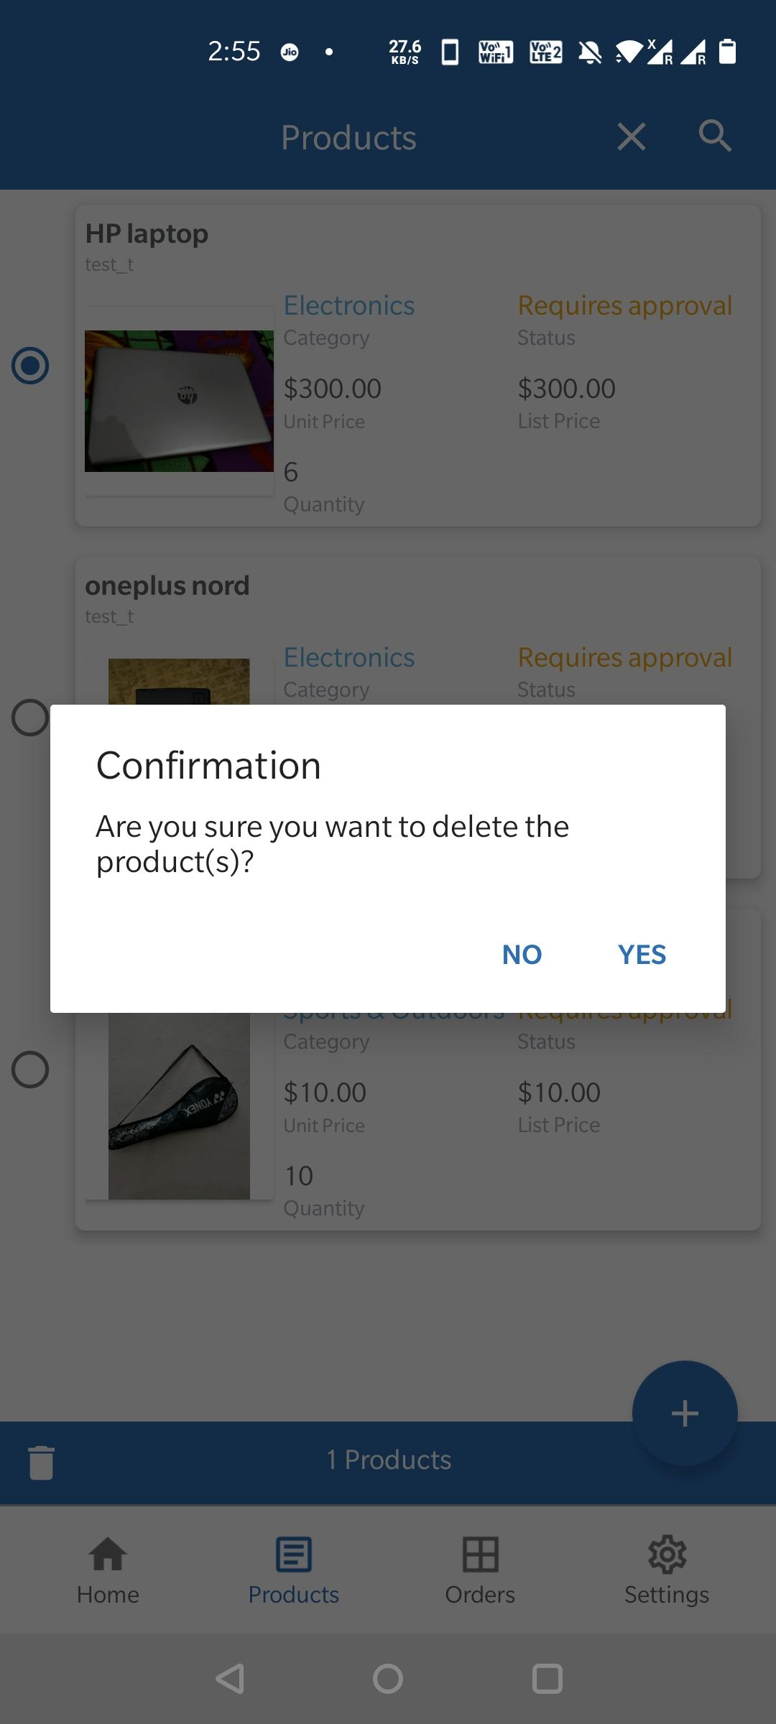
Img 3.5.1 :Delete product: select product for Img 3.5.2: Delete product : Confirmation yes for
delete Delete / No for cancel.

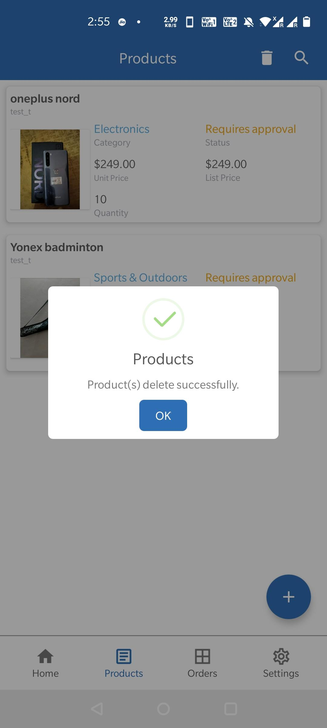
Img 3.5.3 :Delete Products: Successfully delete

Delete Products: as you can see in the above screenshots for how a user can delete products which are added by simply click on delete button and choose products which he want to delete and then click on delete ,the delete confirmation popup alert appear for confirmation of delete products, user can choose yes or no. if choose yes then the products is deleted and popup message appear with products delete successfully. In case if he chooses no then it takes one step back to users.

- Orders: it's also situated on the bottom of the homepage where users can click and goto the orders sections where they can see all the orders and manage orders statuses.

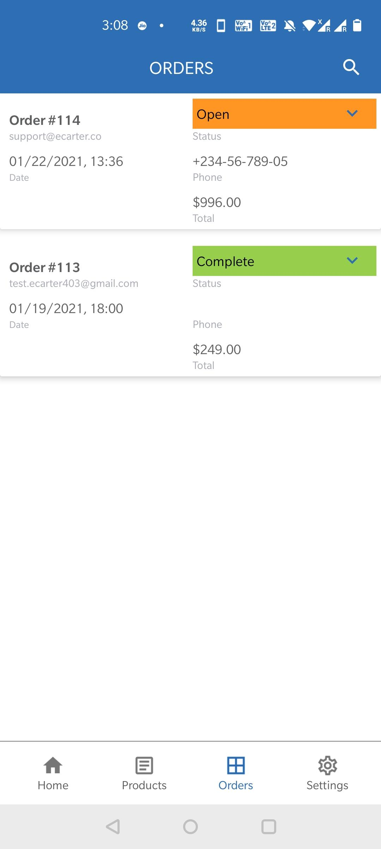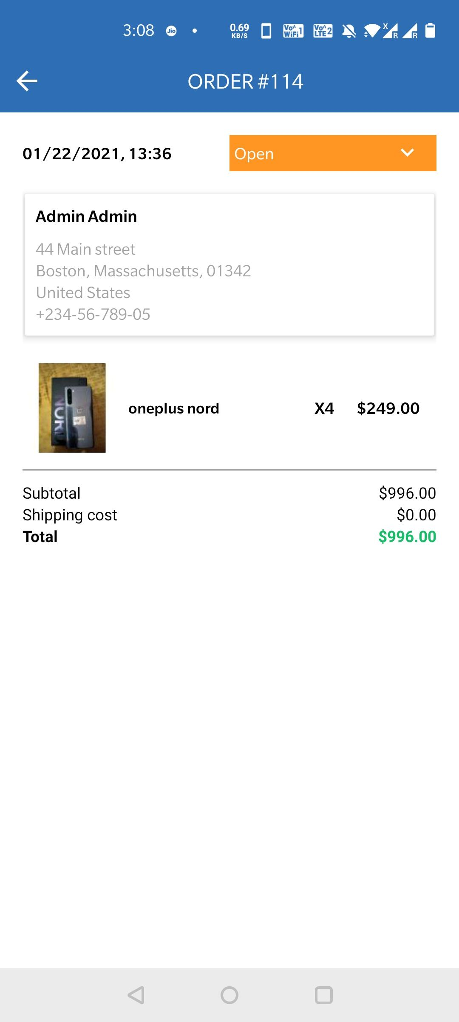
Img 4.1: ordes : see all orders Img 4.2 orders : open order
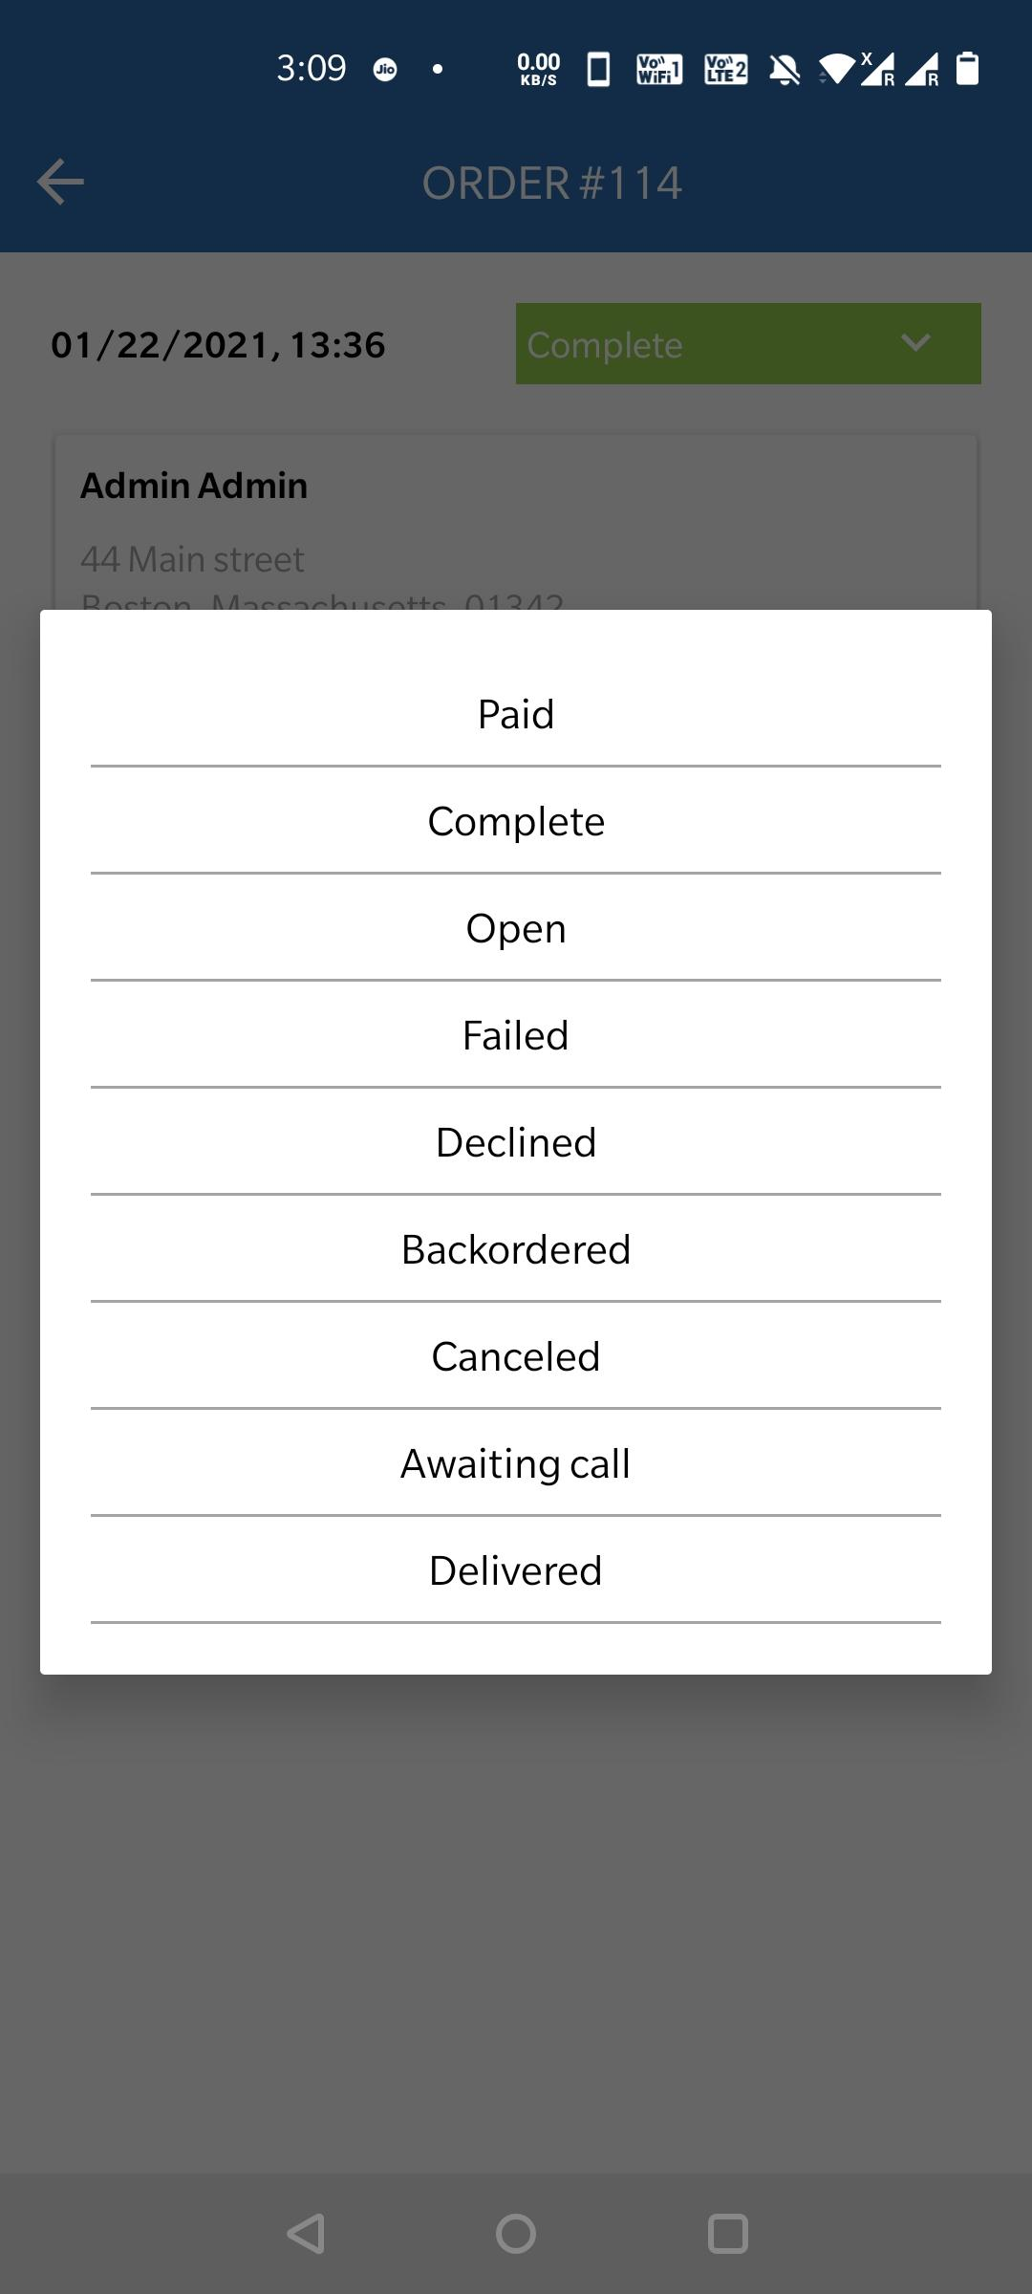
Img 4.3 : Orders :Change order status Img 4.4 : Orders : Order status Changed

Img 4.3 : Orders :Change order status : as you can see in this above screenshots there are all statuses given ,users can simply choose any one of these according to current order status.

Img 4.4 : Orders : Order status Changed: as you can see in the above screenshots after changed order status of product a popup will appear which means the status of order has been changed. And as you can see in this image, vendors also get push-notification for the order status change.

- Settings: it's also situated on the bottom of the homepage where users can click and goto the setting navigations drawer where the can mange settings like- (Img 5.1: Settings: Settings Navigation)

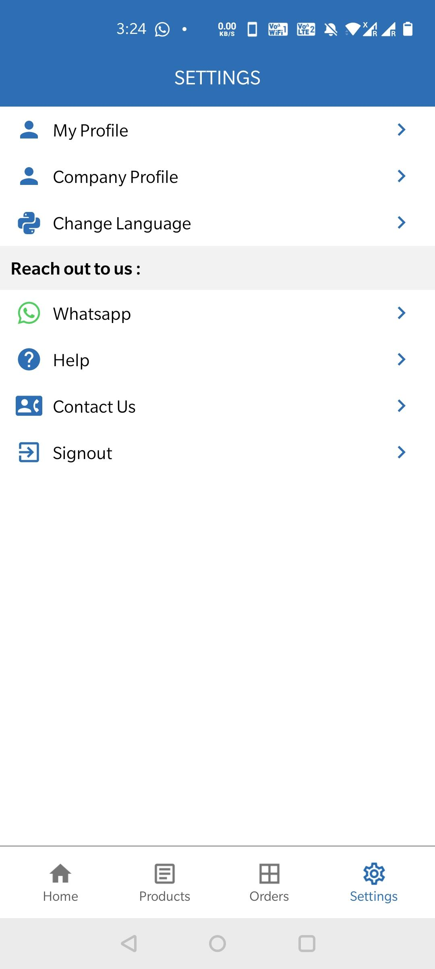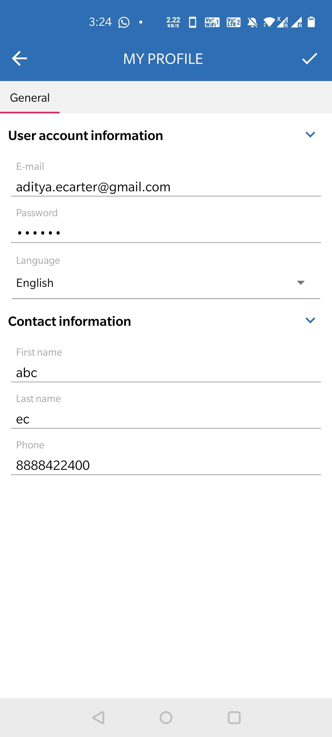
Img 5.1: Settings: Settings Navigation Img 5.2: Settings: View/Edit My Profile

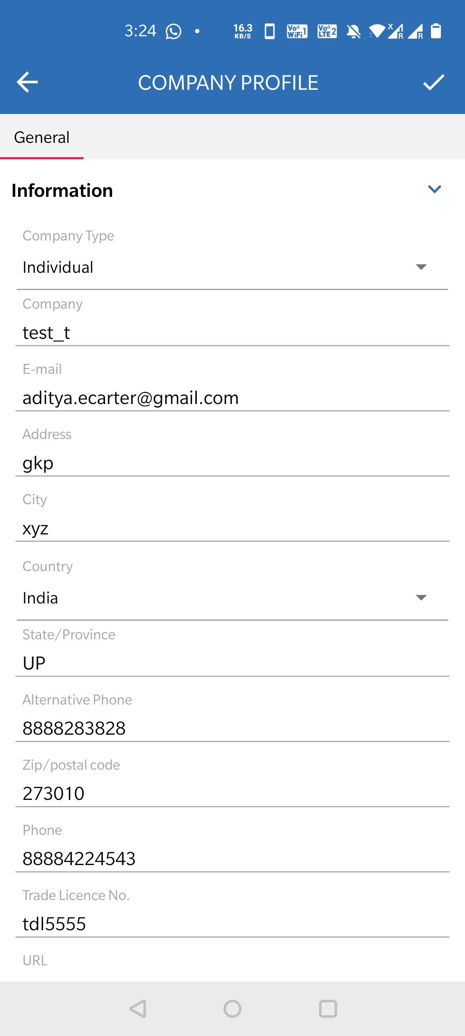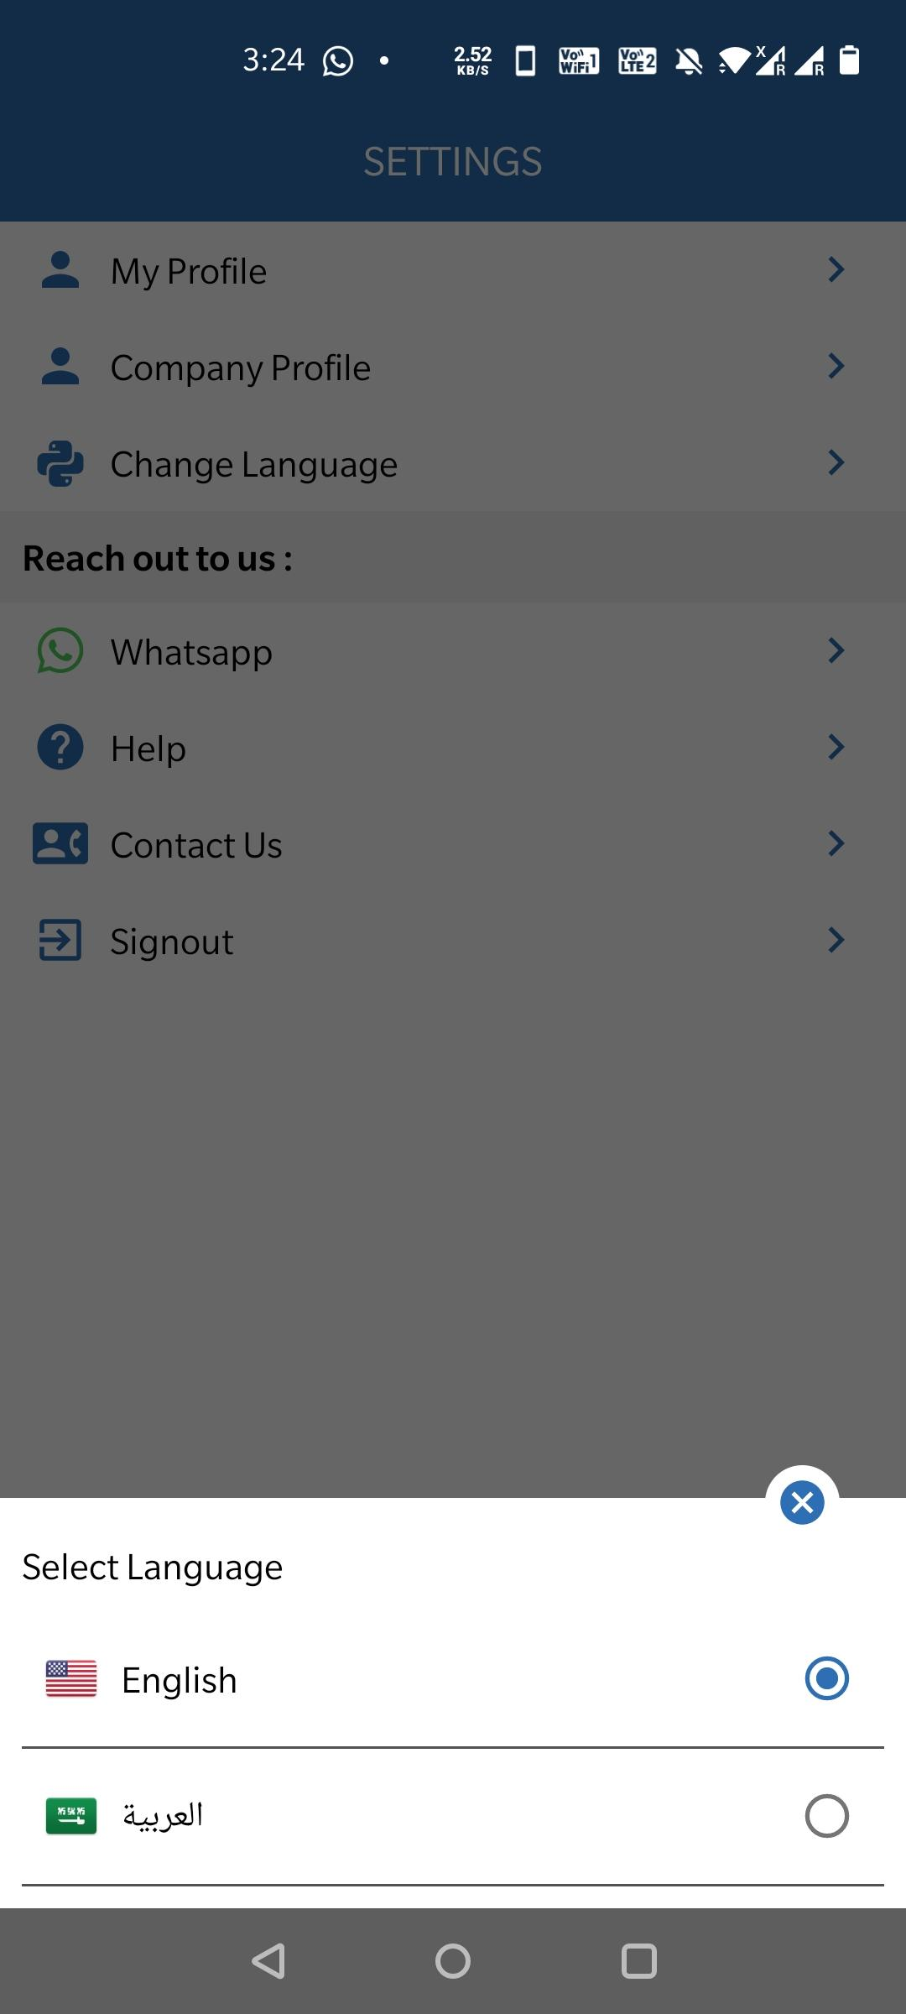
Img 5.3: Settings: View/Edit Company profile Img 5.4: Settings: Change Language

Img 5.2: Settings: View/Edit My Profile : as you can see the above screenshots with this option users can view/edit their profile like user account information and contact information (email and password).

Img 5.3: Settings: View/Edit Company profile : as you can see the above screenshots with this option users can view/edit company profile like name,type of the company ,contact information of the company.

Img 5.4: Settings: Change Language: as you can see in the above screenshots with this option users can change the language of the app in which he wants to process the app.

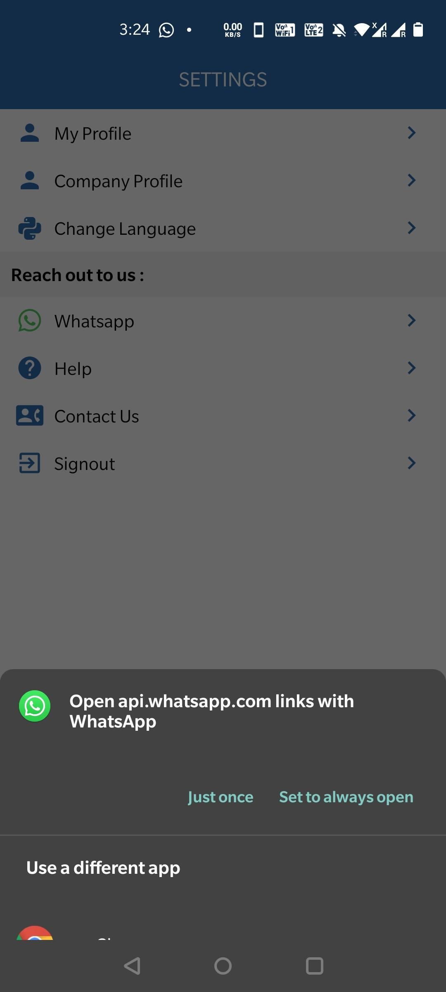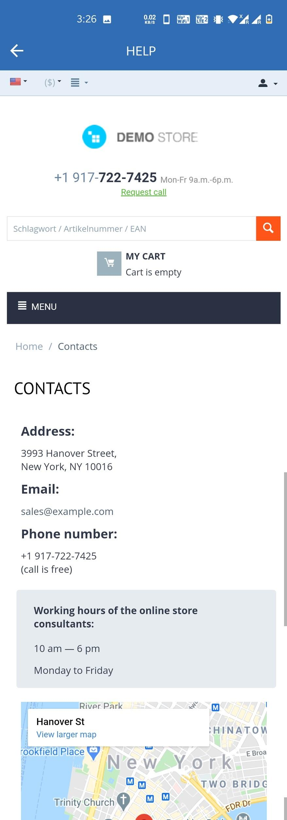
Img 5.5: Settings: redirect to Whatsapp Img 5.6 : Settings: Help
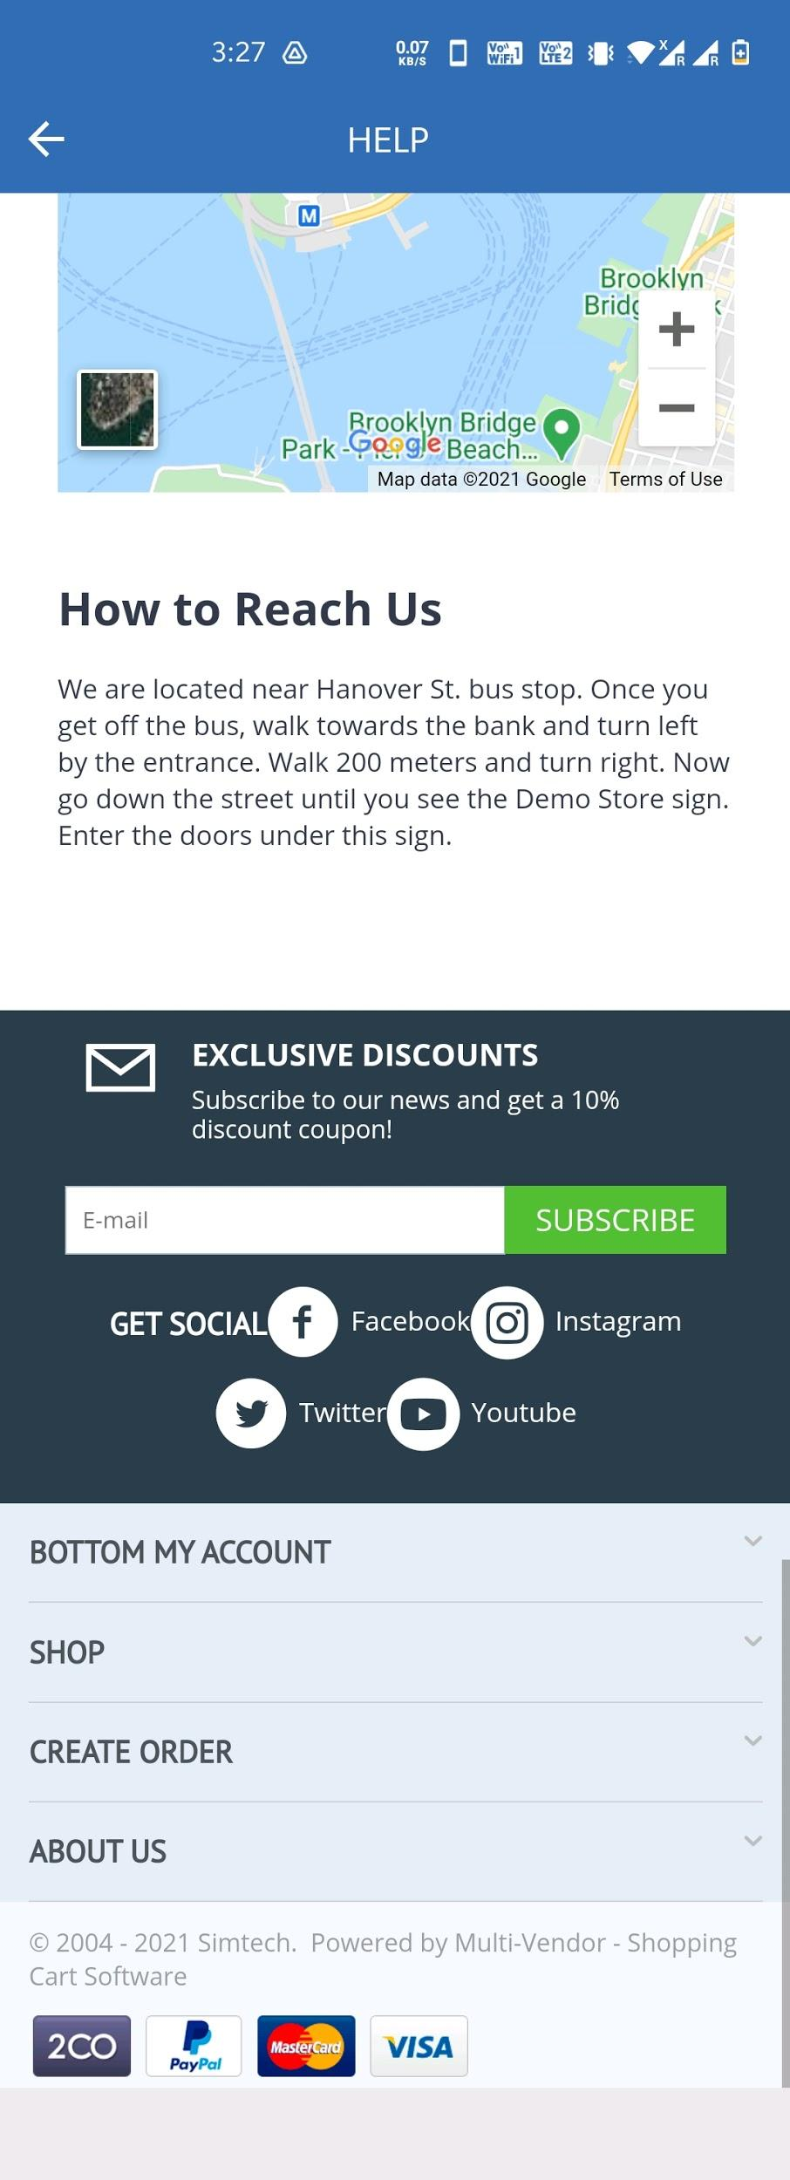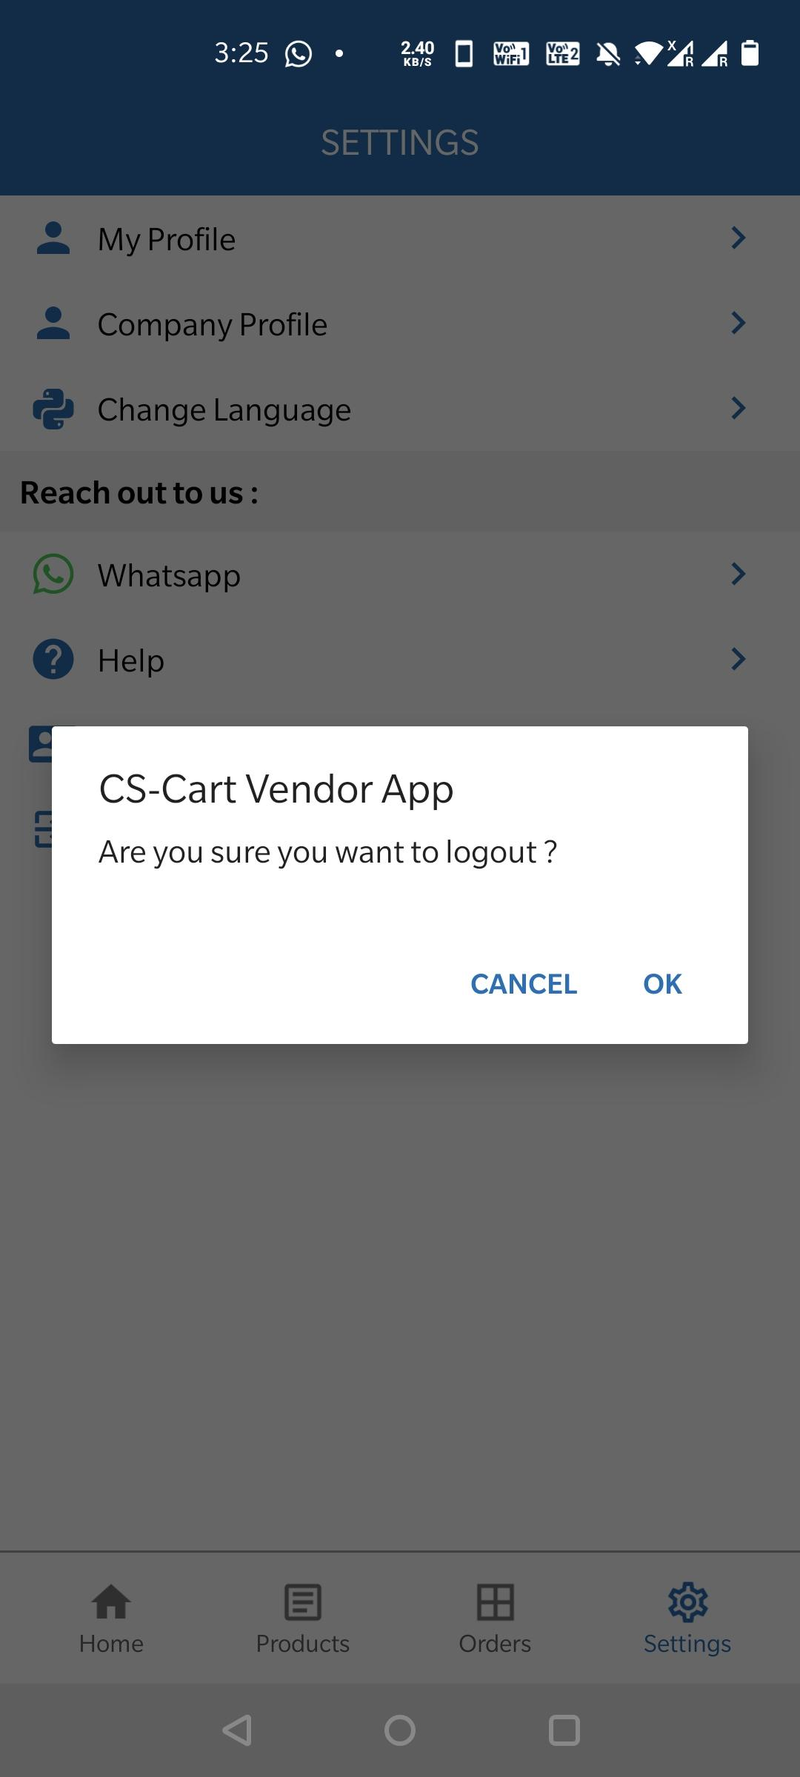
Img 5.6 : Settings: Help Img 5.7: Settings: Logout

Img 5.5: Settings: redirect to Whatsapp: As you see in the above screenshots user can directly contact with the storefront admin through this whatsapp redirect link.

Img 5.6 : Settings: Help: As you see in the above screenshots user can reach out to the storefront contact page.

Img 5.7: Settings: Logout: As you see in the above screenshots user can logout from their registered account just by clicking ok on the logout alert.
After Logout user can reached at login page of the app as you can see in the below screenshot-

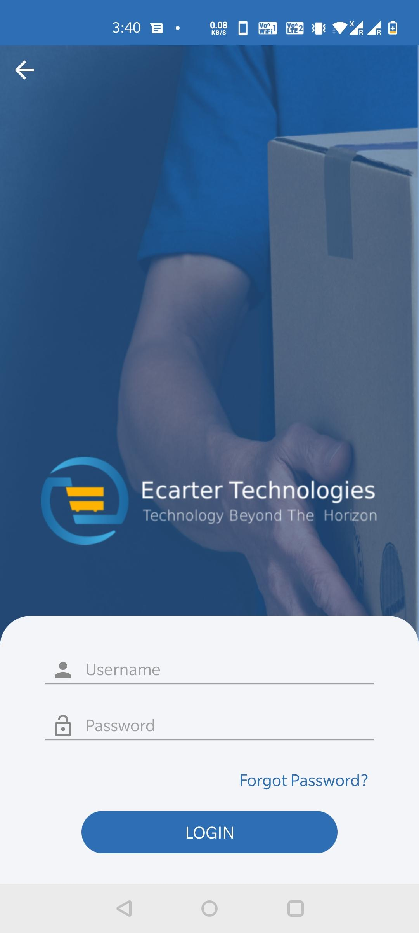
Img: 6 : After logout

